**Experiment No. 6**

**Aim**: Serialization in python using Pickel

**Objective:** To introduce basic concept of Pickel module

**Theory**:

● What is Serialization?

● Serialization is the process of converting a Python object into a byte stream that can be stored in a file or transmitted over a network.

● What is Pickle?

● Pickle is a Python module used for serializing and deserializing Python objects. ● Why Pickle?

● Pickle provides a convenient way to save Python objects to disk and load them back into memory later.

● How to use Pickle?

● The pickle module provides two main functions: dump() for serialization and load() for deserialization.

1) **pickle.dump(obj, file)**:

● The **pickle.dump()** function is used to serialize a Python object **obj** and write it to a file specified by the file object **file**.

● This function takes two parameters:

● **obj**: The Python object to be serialized.

● **file**: A file object opened in binary write mode ('wb') where the serialized data will be written.

2) **pickle.load(file)**:

● The **pickle.load()** function is used to deserialize data from a file specified by the file object **file** and reconstruct the original Python object.

● This function takes one parameter:

● **file**: A file object opened in binary read mode ('rb') from which the serialized data will be read and deserialized.

**Code:-**

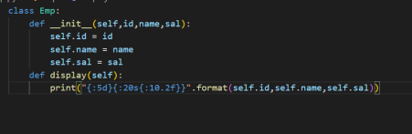

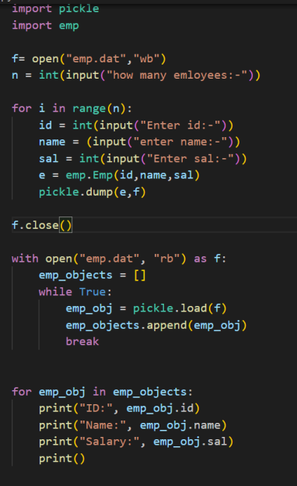

**Output:-**

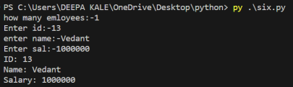**Conclusion:** Serialization in Python using Pickle has been demonstrated.